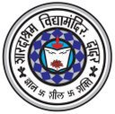
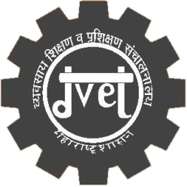

(AFFILIATED TO NCVT, NEW DELHI )
BHAVANI SHANKAR DADARKAR MARG, DADAR, MUMBAI-28.
TEL: 2430 30 62, E-mail: svmitc@rediffmail.com.
DGET AFFILIATION No.: DGET-6(II)/85-TC-10-09-1987
Trade wise Details for Admission:
SR. No. | Trades | Duration | Eligibility | Intake Capacity
1 | Draughtsman (Mech.)  (With Auto-CAD,Solidworks & PIPING) | 2 Years | S.S.C. Passed | 20
2 | Fitter  (With Fabrication , Mig Welding & Plumbing) | 2 Years | S.S.C. Passed | 20
3 | Wireman  (With A.C.& Refrigeration) | 2Years | S.S.C.Pass/Fail | 20

Examination: Final examination is conducted N.C.V.T.Board, New Delhi.
Apprenticeship: After completing the course Apprenticeship under Act 1961
available in following reputed industries.
Bharat Petrolium Mahindra & Mahindra Ltd. Tata Consultancy Ltd. BMC
Godrej & Boyce Ltd. Ceat tyres Ltd. BEST Reliance Industries. Indian Railway.

OUR SPECIAL FEATURES
Well-Established Infrastructure. Qualified & Enthusiastic staff.
Well-Equipped Lab, Workshop. Discipline.
Personal attention. Good Result. Visits to Various Industries.
Separate AC Computer Lab for Intensive Training in AUTO CAD & SOLIDWORKS software with
Internet facility.
Students those who has enrolled on central online admission as per government rules will get the benefit of fee reimbursement.
Online Admission Website (http://admission.dvet.gov.in)

I. T.I. Passed students will get directly admission in diploma second year.

FOR ADMISSION CONTACT : 8097363909
8108026688 / 7718920493 / 9757281048 / 9158222813 / 9967310463

